***Team Agreement***

**EC463/EC464 - Senior Design**

**Fall 2022 – Spring 2023**

We, the members of team number 04, called Brain Force, have entered into a project titled “An EEG based brain computer interface” for the customer, Alan Pisano as part of Senior Design Project, ENG EC463/EC464.

**The general objective of our project is:**

Help a wide variety of disabled individuals navigate a computer by reading neural activity related to thoughts of motion and translating these thoughts into distinct commands on a computer.

**We expect that our major project deliverables will include the following:**

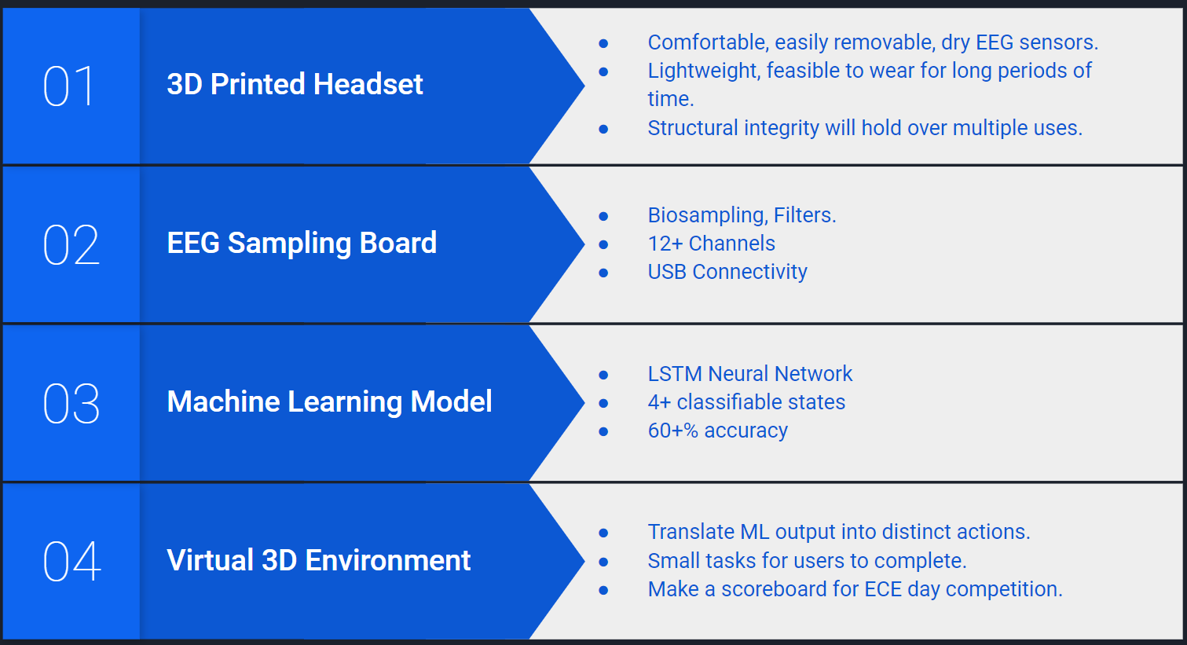

GENERAL CRITERIA FOR SUCCESS

We understand that evaluation of our work in Senior Design will depend on several factors. First is our team's success at meeting our proposed objectives, as described by our specifications, and providing our deliverables in working fashion, with the required documentation, by the course deadlines. Second is our demonstration of individual proficiency at design and at keeping adequate engineering records of our work. Third is our individual and collective team skill in listening, helping others to reach their goals, and negotiating technical and team problems. Finally, we understand the department policy for reimbursement of expenditures made in executing our project and agree that anything spent about the amount reimbursed by the department will be equally shared among all team members.

INDIVIDUAL LEADERSHIP

We understand that Senior Design teams shall be organized to give each member clear responsibility for one or more design areas. Several people may collaborate on a problem, but only one person should be the designated 'leader' for a design area. Each of us should be the leader of at least one design area so that we can clearly demonstrate our individual proficiency in design and in keeping professional engineering records (in our logbooks).

RESOLVING TEAM CONFLICTS

We understand that we need to work to resolve interpersonal and technical disputes within our team, in a professional and respectful manner. This will sometimes involve compromise, and we agree to be open to reasoned technical arguments about our individual areas and the team's collective efforts. We will seek faculty or mentor help when problems appear serious and are not resolved quickly by our efforts.

NON-PERFORMANCE OF DUTIES BY A TEAM MEMBER

We understand that each of us must pursue our design and team tasks in a professional and timely fashion to ensure our team's success. Should a team member fail to show diligence and concern for the team, a meeting of the team and the course faculty will be held to assess the situation and recommend specific short-term performance goals for the team member, and possibly the whole team. If these goals are not met, the course faculty may decide to remove the offending team member from the team. The student will then have to complete the course reporting directly to the faculty as a team of one. This is a serious step and suggests a significant failure on the part of the individual, and possibly the whole team. It should not be considered except as a last resort.

QUESTIONS

We understand that students and teams are welcome to approach the course faculty about this agreement at any time.

INDIVIDUAL TEAM MEMBER RESPONSIBILITIES

The remaining pages list our team members and our individual 'leader' responsibilities.

TEAM MEMBER ADDENDUM (submit one for each team member):

Team Member Name: (printed) **Alexander Johnson**

Team Number **04** Team Name: **Brain 4ce**

I have read this entire document, including my teammates’ descriptions of their 'leader' roles. I understand the document and agree with the descriptions of roles.

Team Member Signature



Date: **December 1, 2022**

The following paragraph(s) describes the technical problem(s) for which I hold leader responsibility. (Please give technical details if possible. Broad topical claims will be difficult to assess.)

I will take leadership of designing the interface between the OpenBCI Cyton board and a computer. In particular, I will focus on designing the interface between the microcontroller on the Cyton board and a computer. At present, the Cyton board’s microcontroller is designed to interface with an obsolete RFduino wireless module, which transmits data to a computer over a wireless connection. To solve this problem, I will focus on two potential solutions, and choose the one that can be implemented the soonest. The first potential solution is to find a way to connect the microcontroller to an Arduino, then connect the Arduino to a computer. The second potential solution is to augment the firmware of the existing microcontroller to transit data over USB, bypassing the need for a separate microcontroller entirely. Both of these solutions will remove wireless connectivity between the Cyton board and our computer, but will allow us to record training data much sooner and more cost effectively than attempting to procure the obsolete RFduino module. Using this data, we will be able to train our LSTM neural network to classify thoughts from the EEG into movement directions.TEAM MEMBER ADDENDUM (submit one for each team member):

Team Member Name: (printed) **Dayanna De La Torres**

Team Number **04** Team Name: **Brain 4ce**

I have read this entire document, including my teammates’ descriptions of their 'leader' roles. I understand the document and agree with the descriptions of roles.

Team Member Signature

Date: **December 1, 2022**

The following paragraph(s) describes the technical problem(s) for which I hold leader responsibility. (Please give technical details if possible. Broad topical claims will be difficult to assess.)

I hold leadership responsibility for the machine learning algorithm and its integration with the virtual environment and headset. I will design, test, and train a LSTM neural network that can operate with >60% accuracy. I will also make sure this neural network can mesh with the virtual environment and the headset and take in/output data in real time with minimal latency.

TEAM MEMBER ADDENDUM (submit one for each team member):

Team Member Name: (printed) **Jonathan Mikalov**

Team Number **04** Team Name: **Brain 4ce**

I have read this entire document, including my teammates’ descriptions of their 'leader' roles. I understand the document and agree with the descriptions of roles.

Team Member Signature 

Date: **December 1, 2022**

The following paragraph(s) describes the technical problem(s) for which I hold leader responsibility. (Please give technical details if possible. Broad topical claims will be difficult to assess.)

I will be leading the software design of our 3D virtual environment, as well as its game and functionality mechanics. This includes but is not limited to: a high score leaderboard for ECE day, an infinite world with generating barriers, a controllable 3D object, and collision checks. I will also be collaborating with the machine learning lead to ensure that the environment is fully synced with the LSTM algorithm output in real time. I hold important technological knowledge of Python, Panda3D, and Blender for this project, and can use my knowledge of these topics to assist with any additional goals as time permits.

TEAM MEMBER ADDENDUM (submit one for each team member):

Team Member Name: (printed) **Mitchell Gilmore**

Team Number **04** Team Name: **Brain 4ce**

I have read this entire document, including my teammates’ descriptions of their 'leader' roles. I understand the document and agree with the descriptions of roles.

Team Member Signature 

Date: **December 1, 2022**

The following paragraph(s) describes the technical problem(s) for which I hold leader responsibility. (Please give technical details if possible. Broad topical claims will be difficult to assess.)

I will lead the electrical design responsibilities. This includes design, and assembly of our EEG monitoring system. Currently this entails taking our fabricated PCBs (based on OpenBCI’s Cyton design) purchasing all remaining components and assembling them so Alex has one to support USB connectivity development. Once the PCBs become operational I will lead an effort to redesign the system to support more probes in order to extract additional information from the EEG. In the redesign I will also work closely with Alex in order to add hardware support for USB connectivity between the PCB and a computer so that the design is more invariant to time (since USB connectors are unlikely to go obsolete anytime soon) than the design we initially adopted as well as to reduce cost. Then if time permits I will head an exploratory study into computationally processing the EEG so as to filter out noise and amplify features helpful for classification.

TEAM MEMBER ADDENDUM (submit one for each team member):

Team Member Name: (printed) **Brendan Shortall**

Team Number **04** Team Name: **Brain 4ce**

I have read this entire document, including my teammates’ descriptions of their 'leader' roles. I understand the document and agree with the descriptions of roles.

Team Member Signature 

Date: **December 1, 2022**

The following paragraph(s) describes the technical problem(s) for which I hold leader responsibility. (Please give technical details if possible. Broad topical claims will be difficult to assess.)

I hold the leadership responsibility for the headset design and construction. This includes purchasing hardware such as screws, springs, bolts, electrodes and wiring. This also includes 3D printing the headset itself, as well as constructing the final headset once all components are acquired. In addition to this I will be playing a larger role in redesigning the PCB alongside the circuit design leader.